

**Safeguarding Concerns: Staff Reporting Form**

**OFS Kindergarten/ES/MS/HS**

All Staff, volunteers and regular visitors are required to complete this form and pass it to [ENTER NAME OF Administrator] if they have a safeguarding concern about a child in our school. Complete as many details as you can.

Reminders

* Listen carefully, with minimal interruption
* Use open-ended questions: **What / Where / How**
* Make notes as soon as possible, using child’s words
* Inform the appropriate person on the reporting chart
* Reassure the child that they have done the right thing by talking to you

|  |  |  |  |
| --- | --- | --- | --- |
| Full name of child | Date of Birth | Class/Homebase | Your name/position in school |
|  |  |  |  |

|  |
| --- |
| **Nature of concern/disclosure** |
| Please include   * where were you when the child made a disclosure * what did the child say, in the child’s own words as much as possible * what did the child do during the disclosure - actions/behaviours * what you saw/observed * who else was there during the conversation/incident * what you said   Time & date of disclosure:  Who are you passing this information to?  Name:    Position:  [Ensure that if there is an injury observed this is recorded (size and shape) and a body map is completed]  [Make it clear if you have raised a concern about a similar issue previously] |
| Your signature:  Time form completed:  Date: |

**OFS Kindergarten/ES/MS/HS**

Time/date form received by Administrator:

Name of Administrator and Designation:

Action taken by Administrator:

Referred to:

Date: Time:

Parents informed? Yes / No (If No, state reason)

Feedback given to:

   

Welfare team Teacher/s Child Person who recorded disclosure

Further Action Agreed:

Full name:

Administrator’s Signature:

Date:

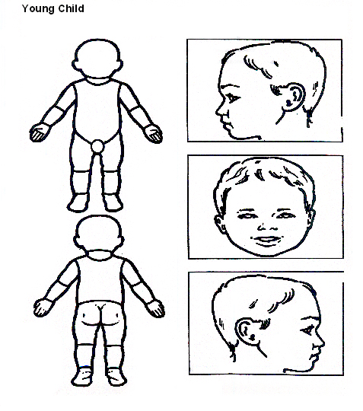

**Indicate clearly where the injury was seen/observed and attach this to the Recording Form**



**Older Child**

**Indicate clearly where the injury was seen/observed and attach this to the Recording Form**